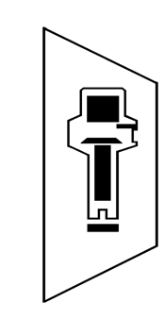

PORTLAND
SCHOOL OF
RADIOGRAPHY

Dear Applicant,

Thank you for contacting Portland School of Radiography (PSR) and requesting an application for our program.

Portland School of Radiography is the longest running program for training limited X-ray machine operators (LXMO) in the state of Oregon. Our instructors have many decades of experience at both the graduate and post graduate level and we have successfully trained more limited permit holders than any other program. Due to our limited class size and skills labs, we are able to maintain an excellent student/teacher ratio, thus maximizing teacher accessibility for of our students. Utilizing x-ray simulator units, we are able to provide our students with an educational experience second to none. Our note packets, handouts and examinations are continuously updated, assuring that our students receive the most accurate and current information available. Our teachers are eager to help and are reachable via email during the week outside of class time.

An applicant wishing to obtain a limited permit in Oregon (LXMO) needs to complete and pass a limited x-ray training program approved by the Oregon Board of Medical Imaging (OBMI). They then apply to the OBMI to take the appropriate examinations offered by the American Registry of Radiologic Technologists (ARRT). Once they have passed the core module ARRT examination, they need to apply to the OBMI for a temporary permit. Once they have a temporary permit, they can start taking x-rays under an approved supervisor. The student then, needs to pass the ARRT examinations in specific anatomical areas and complete practical experience requirements. Finally, after both have been successfully done, the applicant must submit an application for a permanent limited permit license to OBMI (see OBMI guidelines for complete details).

PSR’s application process is updated from time to time in order to stay compliant with rule changes from the OBMI. PSR requires that our students be employed and have a designated in office x-ray supervisor (with adequate training in radiography per OBMI requirements). Upon successful completion of the program, PSR will act as a clinical coordinator and remain in regular contact with the students, their office and the supervisor during the practical component of the student’s training until they obtain their permanent permit. A completed signed application for each student (including payment) is required prior to the start of classes. Our program is a combination of live online lectures and in-person labs taught on weekends only, but study time and online access are necessary during the week. Homework is required and expected to be completed in a timely manner in order to pass the course.

If you have any additional questions please contact the program registrar, Edith, at 503-635-0105. We look forward to working with you.

Portland School of Radiography

Portland school of radiography
Student Application to be returned with full payment, copy of ID, and signed agreement:

Applicant Information
Last Name |  |  |  | First |  |  |  |  |  | M.I. |  |  | Date Of Birth
Street Address |  |  |  |  |  |  |  |  |  | Apartment/Unit #
City |  |  |  |  | State |  |  |  |  | ZIP
Social Security #
Phone |  |  |  |  | E-mail Address
Employer Name
Employer Address |  |  |  |  | City, State, and ZIP Code
Work phone |  |  |  |  | Work Fax
Clinic Manager |  |  |  |  | Phone
X-Ray Supervisor name with credentials |  |  |  |  |  |  |  |  |  |  | Phone

Tuition/Moldule
 |  | - Select Choices: |  |  |  |  |  |  | Paid by 08/27/2021 |  |  |  |  | After 08/27/2021
 |  | Application/registration fee (required) |  |  |  |  |  |  |  |  | 50.00 |  |  | 50.00
 |  | Radiation Use & Safety (Core Module) |  |  |  |  |  |  |  |  | 1500.00 |  |  | 1550.00
 |  | Extremities |  |  |  |  |  |  |  |  | 1500.00 |  |  | 1550.00
 |  | Podiatry |  |  |  |  |  |  |  |  | 550.00 |  |  | 600.00
 |  | Spine |  |  |  |  |  |  |  |  | 800.00 |  |  | 850.00
 |  | Chest |  |  |  |  |  |  |  |  | 400.00 |  |  | 450.00
 |  | Skull/Sinuses |  |  |  |  |  |  |  |  | 700.00 |  |  | 750.00
 |  | Required: Radiography Essentials for Limited Practice by Long, Frank & Ehrlich, 6th Edition - ISBN # 9780323661874 (5th edition acceptable)
 |  | You must order your textbook and have it by 09/11/2021
TOTAL AMOUNT ENCLOSED: $
*Students needing to repeat module(s) please contact the office for tuition cost.
 |  | *Students needing to repeat module(s), please contact the office for tuition cost.
 |  | **We do not recommend signing up for more than 3 modules/term unless you have discussed it with us prior to registration.
 |  | CONTINUING EDUCATION |  |  |  |  |  |  |  |  | 20.00/hr
 |  | (Not all hours are available for continuing education. Please call before registering)
If choosing to pay by credit card on-line, there will be an additional CC processing fee (approx. 3%)

Student Enrollment Agreement – Cancellation and Refund Policies
Instructional term begins on 09/11/2021 and ends on 12/19/2021.
The school will charge a non-refundable $50 application/registration fee per term.
Full payment (either by check/money order/credit card) must be received by the beginning of the term in order to begin classes.
A student may cancel or terminate their enrollment by giving written notice to the school.
Tuition refund policy is as follows:
 | - Each and all modules are offered provided there is sufficient and adequate enrollment. In the case of cancellation of a module by PSR, full refund will be provided.
 | - If written notice is post-marked up to 15 days prior to the beginning of the term (by pre-registration deadline of 08/27/2021), tuition shall be fully refunded (with the exception of credit card processing fee).
 | - After the pre-registration deadline (08/27/2021), 50% refund of tuition will be issued for any modules in which the student is enrolled but which have not started prior to withdrawal notice received (with the exception of credit card processing fee).
 | - There will be no refund for any module once the module has begun.
Tuition includes Radiation Use and Safety notes and anatomic category positioning notes relative to the module(s) chosen.
Study time and online access required during the week to complete necessary homework/test.

Agreement
I certify that I am at least 18 years of age and am not a convicted felon. I will provide a copy of my driver’s license (or if not available, other official ID). I have read and received a copy of this enrollment agreement and agree to any stipulations listed in them:
Student Signature |  | Date
Signature of Supervisor |  | Date
Signature of School Representative |  | Date
PORTLAND SCHOOL OF RADIOGRAPHY

Fall term lab location: Tigard Orthopedic and Fracture Clinic
(probable) 9445 SW Locust St.
Portland, OR 97223

Mailing address: 539 10th Street
Lake Oswego, OR 97034

For more information, please contact us at (503) 635-0105
or email psr.xray@comcast.net
Please be aware that due to pandemic constraints, the current schedule and lab location remain tentative and may have to be adjusted to accommodate for everyone’s health and safety as well as location constraints.
Lab hours will be determined by enrollment and social distancing needs.
We thank you for your understanding with these uncertainties.

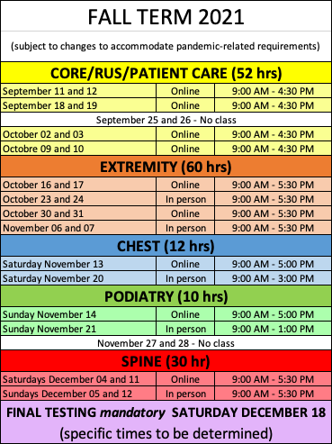

PLEASE RETAIN SCHEDULE FOR YOUR REFRENCE

